“Tropical Texas Behavioral Health provides quality behavioral healthcare with respect and dignity, and cultural sensitivity, through the efficient and effective delivery of services.”

STRATEGIC PLAN

FY 2013

STRATEGIC PLAN
FY 2013
CONTENTS

I. EXECUTIVE SUMMARY

II. OVERVIEW

A. STRENGTHS, WEAKNESSES, OPPORTUNITIES AND THREATS

B. VISION

C. MISSION

D. VALUES

III. STRATEGIC ACTION PLAN

IV. BUSINESS PLAN

I. EXECUTIVE SUMMARY

The 2013 Strategic Plan for Tropical Texas Behavioral Health (TTBH) represents a significant change from those of previous years. The legislative session starting in January 2013 will again be very challenging for all agencies who have general revenue funds as part of their budgets. TTBH leadership is proactively planning for possible funding issues. There will be challenges in adapting to the upcoming Texas Resiliency and Recovery (TRR) changes, including the implementation of a new children’s assessment tool. South Texas is an area of population growth and a growing demand for TTBH services. A growing waiting list will lead to challenges in controlling access to TTBH services as well as the transition out of those services. Local Network Development was initiated four years ago with successfully adding new providers. TTBH continues to work on client choice while striving to use resources efficiently and effectively. As Tropical Texas Behavioral Health continues to lead in the innovative management and provision of behavioral healthcare for our local communities, the Center follows its Mission Statement: “Tropical Texas Behavioral Health provides quality behavioral healthcare with respect and dignity, and cultural sensitivity, through the efficient and effective delivery of services.” This mission is indicative of the Center’s total commitment to providing behavioral healthcare services that will better and/or improve the quality of life for the individuals served.

The Center has established goals and objectives to act as a guide in achieving our mission. Information was collected through the analysis of the internal/external environments and organizations, as well as consulting groups. This Strategic Plan will provide guidance for promoting linkage and cohesion among the various functional components of outcome based quality management, business and utilization management plans. TTBH is proud of the attainment of a three year accreditation by the Commission on Accreditation of Rehabilitation Facilities (CARF) in August of 2008 for Assertive Community Treatment-Mental Health Adults; Outpatient Treatment-Mental Health Adults; Outpatient Treatment-Mental Health Children and Adolescents; and Residential Treatment-Integrated DD/Mental Health Adults. During the CARF survey in August of 2011, TTBH added Crisis Services and MH Case Management to the list of programs accredited. In the August 2014 CARF Survey, TTBH plans to accredit Governance and Substance Abuse Services.

The goals and objectives for the operational strategies fall under the following categories:

□ Management of Human Resources
□ Management of Fiscal Resources
□ Management of Service Delivery
□ Standards Compliance

These goals will be continuously reassessed due to the constant change in MH and Intellectual and Developmental Disabilities system throughout the state and healthcare across the nation. Progress on goals and objectives will be published for review by, and celebrated with, agency employees and stakeholders. This progress will also be presented and reviewed by the Board of Trustees on a regular and on-going basis. Many improvements have been realized by Tropical Texas Behavioral Health during the preceding twelve months, and many more opportunities for improvement exist. Undertaking the activities outlined in this strategic plan will result in the achievement and accomplishment of the goals/objectives and ultimately lead to fulfillment of the Center Vision Statement - “Tropical Texas Behavioral Health continues its commitment to excellence and will be an innovative provider of comprehensive and compassionate behavioral health services. We will treat all stakeholders with honesty, fairness and respect.”

II. OVERVIEW

STRENGTHS, WEAKNESSES, OPPORTUNITIES, THREATS

(SWOT analysis)

Strengths
- Dedication to clients
- Quality of Service provision
- Financial position
- Solid relationships with local stakeholders
- Lean organization – administrative overhead low
- Adaptable/Flexible staff
- Change oriented
- High level of client satisfaction
- Understanding external requirements
- Advocate on behalf of clients
- Involvement in the community and MHMR system, viewed as leaders and a valuable resource.
- Integrity
- Improved productivity of staff
- New/renovated facilities
- Improved reputation
- CARF Accreditation of key programs
- Improved Communication
- Expanded Crisis Services
- Increased employee satisfaction
- Expanded funding for local in-patient psychiatric care
- Innovative use of technology
- Fully Electronic Health Record (EHR)
- Expanded Veteran Services
- Involvement in State and National improvement projects (Wraparound, ASIST, COPSD, Recovery)

Weaknesses
- Physical Environment (Space)
- Legislative perception of CMHMR system
- Under served area/Recruitment
- Bureaucracy (reporting requirements, external audits, etc.)
- Border Issues/Poverty
- Waiting List
- Transportation

Opportunities
- 1115 Medicaid Transformation Waiver
- Improvement in Financial position
- Improvement in Service delivery
- Leadership Development
- Employee engagement
- Improve use of information systems to support Performance Improvement
- Increase in Equity Funding
- Expand network of providers
- Improve employee satisfaction
- Development of TTBH intranet and ability to fill out applications on-line
- Diversify funding streams
- Network Development
- Federal Healthcare Reform-Medicaid Expansion

Threats
- Medicaid Reform-Managed care
- Network Development
- Economy
- Regulatory environment
- Federal Deficit Changes in Hospital Bed Utilization
- Changes in Local Political Environment
- State budget concerns
- Federal Healthcare Reform

- VISION STATEMENT

Tropical Texas Behavioral Health continues its commitment to excellence and will be an innovative provider of comprehensive and compassionate behavioral health services. We will treat all stakeholders with honesty, fairness and respect.

- MISSION STATEMENT

Tropical Texas Behavioral Health provides quality behavioral healthcare respect, dignity, and cultural sensitivity through the efficient and effective delivery of services.

- PHILOSOPHY/CORE VALUES:

Ethical Tropical Texas Behavioral Health (TTBH) is committed to abide by all honest, legal and moral principles in its operations.

Competent TTBH is committed to providing efficient and quality services through qualified, trained and credentialed professional staff.

Trustworthy TTBH is committed to responsibly provide an organized system of care through the careful and planned expenditure of all available resources.

Dedicated TTBH is committed to the caring support of the individuals it is privileged to serve.

Quality TTBH is committed to the provision of excellent customer service driven by the needs of all people it serves.

Advocate TTBH is committed to furthering the interests of those served and to help them lead meaningful lives as members of the community. This includes helping them to achieve their right to belong, to be valued, to participate and to make meaningful contributions.

III. STRATEGIC ACTION PLAN:

1. Function and Purpose: |  |  |  | Management of Human Resources |  |  |  |  |  |  | FY2013
This will be evidenced by the development and maintenance of an effective management team; maintaining staffing levels that ensure appropriate
quality of services and safety for consumers; providing an effective mechanism for staff orientation and ongoing training and development; and
ensuring that a positive and growth-oriented system of employee performance and evaluation is developed and implemented.
 |  |  |  | NOT MET |  | MEETS | score | EXCEEDS | score | COMMENDABLE | score
 |  |  |  | (No score) |  |  | 1 |  | 2 |  | 3
A. | Staff satisfaction survey results are positive and compare
 | to national benchmarks. (5pt scale, 5 is highest)
 | A.1. Score on "Grand Mean" |  |  | < 3 |  | 3.0 - 3.24 |  | 3.25 - 3.59 |  | 3.6 +
 | A.2. Score in "Physical Environment" |  |  | < 3 |  | 3.0 - 3.24 |  | 3.25 - 3.54 |  | 3.55 +
 | A.8. Score in "Pressure - stress aspects of job " |  |  | < 3 |  | 3.0 - 3.24 |  | 3.25 - 3.54 |  | 3.55 +
B. | Overall employee turnover is minimized |  |  | > 30% |  | 30% - 25.01% |  | 25 - 20% |  | < 20%
C. | Number of adverse HR related outcomes |  |  | > 2 |  | 2 |  | 1 |  | 0
D. | TRR training for existing LPHAs: competency training |  |  | < 80% |  | 80 - 85% |  | 86 - 90% |  | > 90%
 | verification prior to 9.1.13 (new staff w/in one yr)
E. | Hiring timeliness: days from posting to hiring authority |  |  | 91 days + |  | 90 - 80 days |  | 79 - 70 days |  | < 70
 | selection
 |  |  | Totals : |  |  |  | 0 |  | 0 |  | 0
 | Total possible score for this section: |  |  |  |  | 21
 | Sum of scores for this section: |  |  |  |  | 0
 | Score |  |  |  |  | 0.0000

2. Function and Purpose: |  |  |  |  | Management of Fiscal Resources |  |  |  |  |  |  | FY2013
An acceptable annual fiscal audit is approved by the Board of Trustees (Board); acceptable controls in place for management of Center funds
with timely reporting of financial status to the Board; and the development and implementation of a balanced operating budget
(major funding reductions outside of the Center’s control will be taken into consideration if applicable).
 |  |  |  |  | NOT MET |  | MEETS | score | EXCEEDS | score | COMMENDABLE | score
 |  |  |  |  | (No score) |  |  | 1 |  | 2 |  | 3
A. | Identified financial indicators (end of FY):
 | 1. Debt Service Coverage Ratio |  |  |  | < 1.0 |  | 1.0 - 1.24 |  | 1.25 - 1.74 |  | 1.75+
 | 2. Days of Operating Reserve |  |  |  | < 50 |  | 50 - 70 |  | 71 - 89 |  | 90 +
 | 3. Acid Test Ratio |  |  |  | < .25 |  | .25 - .99 |  | 1 - 1.74 |  | 1.75 +
B. | Medicaid and other 3rd party claims
 | 1. Monthly average of 3rd party bills collected |  |  |  | < $650K |  | $650K - $699,999 |  | $700K - $749,999K |  | $750K+
 | 2. Percent of Medicaid/Medicare |  |  |  | < 70% |  | 70% - 79.9% |  | 80% - 89.9% |  | 90% +
 | claims billed within 30 days
C. | Administrative/indirect cost control |  |  |  | 11.6% + |  | 11.5% - 11.1% |  | 11% - 10.5% |  | less than 10.5%
D. | Consumer benefits - average # of |  |  |  | < 10 |  | 10 - 14 |  | 15 - 19 |  | 20+
 | applications submitted/month
E. | Meaningful Use funds collected |  |  |  | less than 70% |  | 70 - 79% |  | 80 - 89 % |  | 90% or more
 | (% of eligible prescribers)
F. | Construction / renovation |  |  |  | less than 25% |  | 25% - 49.9% |  | 50% - 74.9% |  | 75% or more
 | % completion of HOP building |  |  |  | complete |  | complete |  | complete |  | complete
 |  |  |  | Totals : |  |  |  | 0 |  | 0 |  | 0
 | Total possible score for this section: |  |  |  |  |  | 27
 | Sum of scores for this section: |  |  |  |  |  | 0
 | Score |  |  |  |  |  | 0.0000

3. Function and Purpose: |  |  | Management of Service Delivery Systems
Include the development and implementation of a system for long and short-range planning; maintenance of a coordinated system of services
designed to meet the needs of the consumers the system is intended to serve, which is both effective and efficient and incorporates a quality |  |  |  |  |  |  |  |  |  |  | FY2013
assurance oriented program evaluation to provide constructive feedback to program and unit managers.
 |  |  |  | NOT MET |  | MEETS | score | EXCEEDS | score | COMMENDABLE | score
 |  |  |  | (No score) |  |  | 1 |  | 2 |  | 3
 | Program Services / Chief Operating Officer
A. | Client Satisfaction
 | (based on national benchmarks, 3=good, 5=excellent).
 | A.1. MH services - Overall, Outcome and Reputation |  |  | ≤ 2.9 |  | 3.0 - 3.5 |  | 3.51 - 3.99 |  | 4 +
 | A.2. IDD services - Overall, Outcome and Reputation |  |  | ≤ 2.9 |  | 3.0 - 3.5 |  | 3.51 - 3.99 |  | 4 +
C. | Clinical Outcomes
 | 1. % of MH clients served who receive their 1st |  |  | ≤ 79% |  | 79% - 86% |  | 87% - 92% |  | 93%+
 | service encounter within 14 days of their intake
 | 2. % of enrollment dates met for HCS |  |  | ≤ 90% |  | 90 - 92% |  | 93 - 96% |  | 97%+
 | and TxHmLvg Medicaid Waivers
 | 3. Waiting list issues
 | 3.a. Additional children admitted to services from waiting list |  |  | < 30 |  | 30 - 49 |  | 50 - 69 |  | 70+
 | 3.b. # of adults admitted from the waiting list |  |  | < 300 |  | 300 - 349 |  | 350 - 399 |  | 400 +
 | 4. % of adults in a service package who receive a supported |  |  | < 2.5% |  | 2.5 - 2.74% |  | 2.75 - 2.99% |  | 3% +
 | housing service
 | 5. % of adults in a service package who receive a supported |  |  | < 2.5% |  | 2.5 - 2.74% |  | 2.75 - 2.99% |  | 3% +
 | employment service
 | 6. PESC Utilization target |  |  | < 735 |  | 735 - 749 |  | 750 - 765 |  | 766+
 | 7. SIC Utilization (average bed days) |  |  | more than 10 |  | 10 - 9.5 |  | 9.4 - 9.0 |  | < 9.0
 | 8. Recruit and train Veterans for provision of peer to peer |  |  | < 15 |  | 15 - 20 |  | 21 - 25 |  | 26 +
 | groups (Operation Resilient Families, In The Zone, Seeking Safety)
D. | 1115 Project Implementation
 | 1. Formation of PIC and implementation project teams |  |  | after 3/15/13 |  | By 3/15/13 |  | By 2/15/13 |  | By 1/15/13
 | (PDCA)
 | 2. Development of project implementation goals and timelines |  |  | after 6/1/13 |  | By 6/1/13 |  | By 5/1/13 |  | By 4/1/13
 | (budgets, hiring, policy & procedures, etc)
 | 3. MH Officer Task Force – inter-local agreements executed, |  |  | after 10/01/13 |  | By 9/31/13 |  | By 8/31/13 |  | By 7/30/13
 | recruitment, hiring and training initiated
 | 4. Expand COPSD services (encounters) |  |  | < 1375 |  | 1376 - 1400 |  | 1401 - 1425 |  | 1426 +
 | 5. Recruit, hire, train, coordinate peer providers for AMH/ |  |  | < 2 |  | 2 - 3 |  | 4 - 5 |  | 6 +
 | CMH services
 | Prescribers (Physicians and APNs)/UM/Chief Medical Officer
A. | % of FTE prescribers using Anasazi 'Doctor's |  |  | < 75% |  | 75 - 84.99% |  | 85 - 99.99% |  | 100%
 | homepage'
B. | # of prescribers reaching productivity goals |  |  | < 4 |  | 4 |  | 5 |  | 6+
C. | Pharmacy - Average medication cost per client per visit |  |  | > $175 |  | $171 - $175 |  | $166 - $170 |  | < $165
D. | Number of total available physician/APN hours (kids & adults) |  |  | < 17000 |  | 17000 - 18499 |  | 18500 - 19499 |  | 19500 +
 | D1. Increase percent of available scheduled kids physician services |  |  | < 2% |  | 3 - 5% |  | 6 - 9% |  | 10% +
 |  | Totals : |  |  |  |  | 0 |  | 0 |  | 0
 | Total possible score for this section: |  |  |  |  | 63
 | Sum of scores for this section: |  |  |  |  | 0
 | Score |  |  |  |  | 0.0000

5. Task and Purpose: |  |  | Standards Compliance |  |  |  |  |  |  |  | FY2013
Demonstrated by ensuring all programs and services are operated in compliance with state contracts, appropriate regulations, standards
and laws, Texas Administrative Code, rules, public responsibility laws, Mental Health Code, etc; and by ensuring
the Center performs acceptably on evaluation site visits such as Quality Assurance / Program / Fiscal Reviews, CARF surveys, etc.
 |  |  |  | NOT MET |  | MEETS | score | EXCEEDS | score | COMMENDABLE | score
 |  |  |  | (No score) |  |  | 1 |  | 2 |  | 3
A. CARF Accreditation
 | Prepare Substance Abuse and |  |  | less than 70% |  | 70 - 74% |  | 75 - 79% |  | 80% +
 | Governance for accreditation |  |  | prepared
B. External Reviews of TTBH Services
B.1. Plans of Correction submitted on time |  |  |  | < 90% |  | 90 - 95.99% |  | 96 - 99.99% |  | 100%
B.2. # of external audits with significant |  |  |  | > 2 |  | 2 |  | 1 |  | 0
deficiencies cited and confirmed
B.3. External review findings are minimized |  |  |  | > 10% |  | 10% - 7.6% |  | 7.5% - 5.1% |  | 5 - 0%
 | (% of findings to total standards)
C. Total annual sanctions or penalties |  |  |  | > $30,001 |  | $20,001-30000 |  | $20,000-$10,001 |  | $0 - $10,000
from DSHS or DADS are minimized
D. Quality Assurance audits of network/contracted services
(inpatient and outpatient services)
 | # of audits per year and |  |  | > 3 |  | 3 - 4 |  | 4 - 6 |  | 7 +
 | completion of any indicated follow-up
 |  |  | Totals : |  |  |  | 0 |  | 0 |  | 0
Total possible score for this section: |  |  |  |  |  | 21
Sum of scores for this section: |  |  |  |  |  | 0
Score |  |  |  |  |  | 0.0000

IV. BUSINESS PLAN for FY 2013-2014

Introduction

The purpose of Tropical Texas Behavioral Health’s (Center) Business Plan is to identify financial mechanisms that can be used to respond to fluctuations in the Center’s revenues in ways that least affects the level and quality of services the Center provides its consumers. The Business Plan includes long-term strategies for dealing with reasonably predictable revenue and expense fluctuations and shorter-term strategies that are more effective in addressing unusual, unpredictable, or time-limited budgetary issues as they arise.

The dualistic long-term / short-term approach enables us to make the best use of current resources while we prepare for leaner times while operating within a fee-for-service environment. It maximizes our flexibility in responding to changes in our financial environment without having to reduce or eliminate programs and services when such changes occur.

The Center’s primary revenue source is state general revenue received through contracts with the Department of State Health Services (DSHS) and the Department of Aging and Disability Services (DADS). The revenue is state appropriated every biennium and is dependent on the legislative funding of the appropriation request submitted by the Health & Human Services Commission. The 82nd Legislative session increased funding for Mental Health services and also increased the targets for the Center

The most significant challenge facing the Center is shifting to a fee-for-service environment and Medicaid Manage Care, while trying to address the increasing demands regarding service targets and external reviews of the consumer and financial data.

Goals & Objectives

Many of the goals and objectives included in the FY 2013 Strategic Plan have financial implications. Collaboration by program and financial staff is essential to achieve successful outcomes for the various goals and objectives.

- Program and Services:
- Reduction of wait list
- Client satisfaction surveys
- Client Treatment Hours
- Reductions in pharmacy costs
- Technology Upgrades

2. Administrative Support
- Maintain a minimum operating fund balance of 60-101days.
- Increase the efficiency of the third-party claims billing and collection processes so that a minimum of Medicaid claims are billed within 30 days of service and 100% of the federal Medicaid revenue is collected within 90 days.
- Keep administrative costs below 10.5%

Environmental Considerations

Programs and Services

Mental Health
The shift to a fee-for-service model has presented many challenges for the mental health programs under the Resiliency & Disease Management (RDM) model and provider of last resort initiatives for both MH and IDD programs. Many of the required services performed by the Center have no payor source other than state general revenue; while other services are not covered due to server credentials. Based on the FY 2012 financial assessments 97.5% of our consumers are living below the Federal poverty level, and therefore do not have the ability to pay for their services. The rates paid for eligible services at this time are consistent with the Medicaid rates. Those rates are based on historical cost. The published rates for 2011 are based on federal fiscal year 2009 cost. The rates set for mental health services are based on services performed primarily by community mental health centers and tend to be more consistent with the Center’s actual cost.

Card Services
In March 2012, Medicaid Managed care was expanded into the Center’s catchment area. Five insurance companies were awarded contracts to provide managed care programs to clients currently enrolled in the State Medicaid program. The Center secured contracts with each of the managed care insurance companies in the area.

Rehab and Case Management
Medicaid reimbursement rates to the Center include a federal and a state portion. Prior to FY 2010, the state portion was sent to the states directly and the state would then allocate it down to the centers with the state general revenue funds. Since then, the Center receives both the state and federal portions. Medicaid services are paid at 100% of the published rate and reconciliation is done to settle any differences between the state portion and the federal portion. The Center has performed well compared to other centers in the state and thus had had to pay a considerable portion back to the state to redistribute to other centers.
Rehab and case management reimbursement is currently capped by the state.

LPND
The 79th Legislature required that LMHA’s not only be the provider of last resort but to also provide consumers with a choice of providers. In response, a Local Planning and Development
Committee was developed in 2008. In FY 2009 the Center issued a request for proposals (RFP) and two providers responded The Wood Group and Atlantis Health Services. Services included were service packages 1, 2, and 3 for adults. No responses were received for children services. Contracts were approved for both providers in 2010. In FY 2011 an additional RFP was issued and the Center had no new responses. In FY 2012, Atlantis Health Services withdrew its services from the area and the contract was terminated.

IDD
The Center actively practices “person directed planning” which provides for consumers and their families to select the provider of their choice. Center staff provides employment services and augments the contracted services to avoid gaps in service. The increase in external providers led to a shift within the Center’s IDD Services department to contract monitoring and compliance.

Respite, Community Support and Day Habilitation Services
The rates set for Home & Community Services (HCS), and Texas Home Living (TxHmL) services are based on services performed primarily by private providers. The costs for the private providers tend to be lower than the costs for community IDD centers, in part, because of the authority functions required by the community centers. In 2012, TTBH adjusted the paid rates to the private providers to 100% of the direct care rates published by Texas Health and Human Services Commission. These rates are extended to the general revenue clients receiving similar services. For FY 13, DADS has released approximately 116 TxHmL slots. This will shift general revenue to Medicaid revenues.

Case Management
Prior to 2010, a monthly fee was paid to centers for certain administration and operation expenses directly related to HCS services. This service was billed to Medicaid under a case management code. In 2009, the Centers for Medicare and Medicaid Services (CMS) informed HHSC that this service will no longer be allowable. A new payment methodology was developed and the State required that LMRA’s provide case management to all HCS consumers in the waiver contract area. In October 2009, the service coordination case rate was set at $221 and the full proposed rate effective June 2010 was $182.80. This rate is to continue until June 2011. The rate after this date will be paid based on encounters defined as Type A and Type B. Only one type A encounter will be paid a month at $92.80 and three type B encounters will be paid at $30 each. This will be capped based on the number of unduplicated census for the year.

Staff Productivity
Client Treatment Hours
Success in a fee-for-service environment is dependent on staff productivity. Productivity targets were implemented in FY 2006. Productivity measures are reported on the 12-month Cost Accounting Methodology (CAM) report submitted to DADS and DSHS. In addition, the Anasazi software system is used to measure and report productivity against established targets. Staff are held accountable for meeting established targets and are eligible for both team based and individual financial incentives for meeting and/or exceeding targets. Improvements have been noted as staff is continually meeting or exceeding targets.

An incentive program was developed to coincide with the productivity initiative. Individual performance has been monitored since 2007. Individual performance was replaced by a group incentive program during the summer of 2007 and continues today. Incentives paid in 2012 were $144,697 and budgeted for 2013 are $144,000.

The TTBH Physician incentive program was revised in 2011 in order to attract staff. The quarterly incentive in place was changed to a yearly incentive. In 2012, 4 physicians were eligible for the incentive for a total incentive payment of $73,000.

Technology
A significant portion of services are delivered in the community. Technology demands have shifted to keep pace with the change. A significant number of the community-based staff use laptop computers in the community to increase their efficiency. TTBH uses Anasazi software system for both clinical and financial services. . The clinical system is a vital component of the service delivery system, especially with the Center’s continued improvement to its electronic medical record. To ensure that the system is dependable and reliable, Management Information System (MIS) staff schedule promotions and enhancements after hours. Promotions / enhancements are completed regularly.

Training sessions are held for first-time users of the clinical system, and as needed for existing staff for changes and to correct problems. Key staff actively participates in the Anasazi Users Group. The involvement enables staff to receive current information about the system and participate in system design discussions. Additionally, the MIS Manager is also an active participant in the Texas Council Information Management Consortium.

In FY 2013, the Center will apply for reimbursement under the Medicare and Medicaid EHR Incentive Programs that provide incentive payments to eligible professionals for the use of certified EHR technology. The Center has nine (9) eligible professionals eligible for a reimbursement of $573,750 in six years with $191,250 in the first year of applying.

Financial Considerations

Operating Revenues

The Center’s ability to generate revenue or create new revenue sources is limited by social and economic conditions, state statute, Board policy, and private provider competition. The Texas Health and Safety Code defines the services to be provided by a Community MHMR Center. Legal protection does not extend beyond the services listed in the statute and those defined in the Center’s Local Plan, although there were some modifications made during the last legislative session. It is anticipated that these changes will increase flexibility for MHMR Centers in Texas.

The projected revenue for FY 2013 is $39,442,202. The following graph shows the various revenue sources comparing projected FY2011 and 2012 actual.
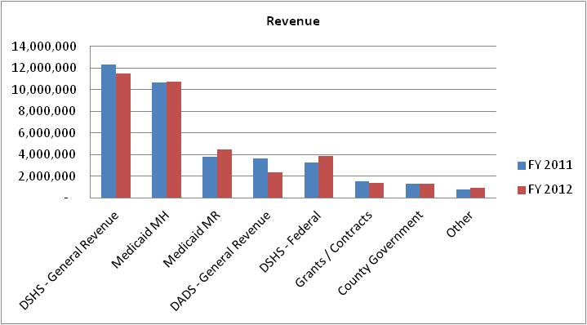

General Revenue

The amount of state general revenue received by the Center has decreased during the past ten (10) years. The funding helped balance the impact of cuts made and “forced” the statewide Community MHMR Centers to become more efficient. See graph below:

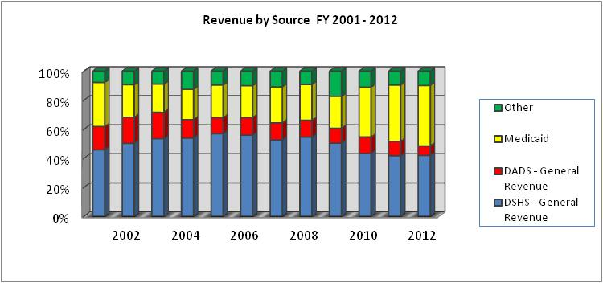

MH General Revenue FY 2013 is expected to be $13,758,540 compared to $11,465,266 in FY 2012. The increase is primarily due to funding from DSHS for the purchase of private in-patient psychiatric bed. TTBH received $144,378 in 2012 and has budgeted $ 2,208,250 for FY 2013.

MR General Revenue was FY 2013 is expected to be $2,198,626 compared to $2,361,246 in FY 2012. The decrease was primarily due to the refinancing initiatives for the TxHmL waiver programs.

Medicaid Revenue
Medicaid revenue was $15,212,790 in FY 2012, and is budgeted to be $15,271,020 in FY 2013. The steady increase in Medicaid revenues since FY 2005 is due to an increase in the number of services delivered and also an increase in the number of our clients covered by Medicaid as well as the fact that Medicaid started being paid at 100% in FY 2010.

The Center’s goals include a further expansion of revenue received from Medicaid and other sources. Procedures implemented to expand Medicaid revenue include the following:
- Four (4) staff dedicated to assisting MH and MR consumers access Social Security and Medicaid benefits. Two (2) staff to assist consumers in the Texas Council on Offenders with Mental Impairments (TCOOMMI) programs.
- Four (4) staff dedicated to assist in getting pre-authorizations needed with the expansion of Medicaid managed care.
- Training staff in verifying and data entering the payor source for every consumer during each visit to a mental health program.
- Monitoring the percent of consumers with Medicaid to determine if there is an increase.
- Comparing the Medicaid data base with our Consumer Data system to determine if any consumers have third-party coverage which was not previously identified.

Other Revenue Sources
In FY 2013, the Center budgeted $1,727,256 from other revenue sources compared to $1,879,757 in FY 2012. The decrease is the result of expiring contracts with the school districts. We do not anticipate additional school district contracts in 2013 and beyond.

The Center continues to expand and diversify the funding sources through various grants and contracts. The Center also continues to explore the possibility of applying for a Section 501(c)(3) designation with the Internal Revenue Service if its status as a political subdivision of the State ever changes. The designation will allow the Center to continue to qualify for grants awarded by foundations, certain federal agencies, and federal pass-through grants such as Community Development Block Grants.

Fund Balance
The Center’s fund balance in the General Fund, as of August 31, 2011, was $8,381,164 and was $7,941,887 at the end of 2012. The Center has had a positive fund balance since FY 2001 and it has continuously grown since 2003. The decrease in 2011 is due to a resolution from the Board of the Center to commit funds to the capital projects fund for planned construction.

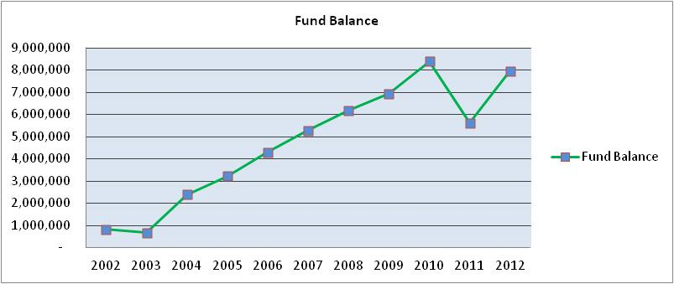

Financial Ratios

The following financial ratios are completed monthly to monitor the liquidity, days of operating cash available and debt load. The ratios were developed by Capital Markets in order to have an industry standard for Texas Community MHMR Centers.

- Current Ratio The ability to meet short-term obligations. This is presented in
“times”. If the ratio is too low, the Center may not be able to pay its obligations. If the ratio is too high, the Center may have money tied up in investments/savings that could be used for the provision of services.
Acceptable range for community centers: 1.75 – 4.00
Ratio at August 31, 2012 2.51 Times

- Quick Ratio / A more stringent measure of liquidity. Eliminates the variable of
Acid Test Ratio converting investments and other tangible assets to cash.
Acceptable range for community centers: .025 – 2.00
Ratio at August 31, 2012 1.93 Times

- Days of Operation Expresses the cash position of the organization in terms of the
Reserve number of days it can operate if there was no further inflow of revenue. Represented in days.
Acceptable range for community centers: 60 – 90
Ratio at August 31, 2012 94.83 Days

- Debt Service A measure of how well the Center has managed the assumption Coverage Ratio of long-term debt. Indicates available cash levels to
accommodate debt service payments. Represented in “times”.
Acceptable range for community centers: > 1.25
Ratio at August 31, 2012 4.73 Times

The ratios are included in the monthly financial statement packet presented to the Board of Trustees. The ratios reported are limited to the General Fund.

Financial ratios are also a key component of the internal monitoring system for the Center. The following graph outlines the acceptable minimum ranges and the Centers ratios. We have consistently been meeting the acceptable ranges and do not anticipate any changes in the near future.

Financial Ratios
Community Services Performance Report
August 31
Financial Measure | 2011 | 2012 | Minimum  Acceptable Range | Maximum  Acceptable Range
Current Ratio | 2.25 | 2.51 | 1.75 | 4.00
Acid Test Ratio | 1.81 | 1.93 | 0.25 | 2.00
Debt Service Coverage Ratio | 4.31 | 4.73 | 1.25 | Unlimited
Days of Operation without Further Funding | 89.15 | 94.83 | 60.00 | 90.00

The strategic goals included having a 60-110 day operating reserve. An increased emphasis on maximizing revenue sources and holding expenses constant should assist the Center in achieving the goal.

Expenditures

The Center’s FY 2012 adjusted operating budget totaled $39,442,202. As with other service industry organizations, the majority of the expenses are for personnel costs. FTE’s in FY 2012 were 565.8 and budgeted FTE’s for FY 2013 are 599.8. The increased positions are to be funded by Medicaid revenues.

FY12 fringe rate is 27.22% and our anticipated FY13 is 29.24% due to a change in workman’s compensation costs and an increase the retirement match. We are not anticipating an increase in health insurance.

Medications expense represents approximately 6% of our FY 2012 operating budget, and will be 6% for the FY 2013. In FY 2010 we contracted with US Scripts to provide to provide a choice to clients who preferred to get their medications from a retail pharmacy. US Scripts provided the Center with valuable information regarding prescribing patterns and suggestions on how to reduce costs by changing doses of the same medication. Significant work has been completed to date to reduce the expense. The most significant initiative was the expansion of the Patient Assistance Program (PAP). PAP allows the Center to request medications on behalf of eligible consumers directly from the manufacturer. FY12 PAP 5,560 applications submitted were for a value of $5,058,394.

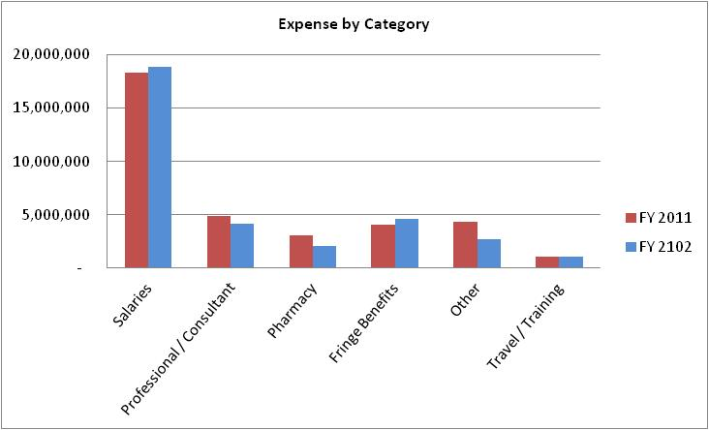

Indirect Cost

The Center uses the indirect cost percentage as an indicator of its administrative efficiency. The indirect cost is a relationship of the administrative costs to the direct / program costs. The indirect cost percentage was calculated in accordance with the Audit Guidelines for Community MHMR Centers, 20th Revision – summer 2003, the cost principles in the OMB Circular A-87 and the Cost Accounting Methodology promulgated by Health & Human Services.

The following graph shows the indirect cost percentage for the past ten (10) years as well as the estimated indirect cost rate for FY 2012. The guidelines used have changed during that time period which contributed to the variances.

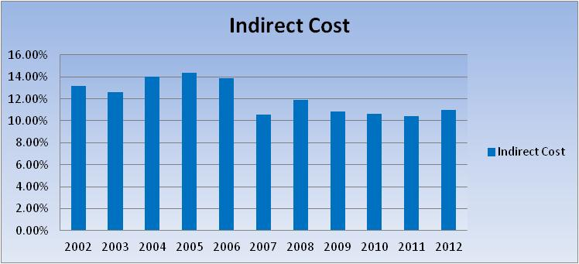

The Center’s Performance Contract with DSHS and DADS includes a 10% funding limitation for state general revenue that can be used to fund administrative costs. Any additional funding needs are covered by various other funding streams. The Center has successfully demonstrated the ability to operate within the funding limitation.

The indirect cost percentage as of August 31, 2012 was 11.01%. Administrative costs are monitored closely to determine where reductions can be made without doing harm to the programs or the Center’s system of internal controls.

Capital Projects

The Center is currently negotiating a contract to construct a building in Harlingen. The building will provide the Center the ability to service clients from one single location.

The Center fleet has also been evaluated and plans to update aging equipment have been identified. Currently we have an inventory of 55 vehicles consisting of 22 sedans, 16 standard vans, 13 passenger vans and 4 pick-up trucks.

Other items in the infancy stage for projects are:

- Replacement of existing “aged” computers and printers
- On-line Time and Attendance system utilizing Biometric clocks
- Telephone system upgrade to an IP System
- Financial software system to provide the growing needs of the Center

1115 Waiver and Other Considerations
In FY2012 HHSC received federal approval of a waiver that allowed the state to expand Medicaid managed care programs, the waiver provided incentives for health care improvements. The waiver called for Regional Healthcare Partnerships (RHP) comprised of counties. The RHP’s were allocated a dollar amount based on its population that is under 200% of the federal poverty level.
TTBH belongs to RHP 5 which is comprised of 4 counties, Hidalgo, Willacy, Cameron and Starr. The RHP’s allocation is approximately $801,878,997. This allocation is for demonstration years 1-5. The waiver calls for an anchor, performing providers and intergovernmental transfer entities (IGT). The incentive program is designed by performing providers developing Delivery System Reform Incentive Payment (DSRIP) projects that need to be funded by IGT entities. TTBH’s initial portion is $72,502,063. If the total allocation is not used in an initial submission, TTBH will be eligible for a share of the amounts left over from the first pass.
Under the rules, TTBH is considered both a performing provider and an IGT entity. The waiver is a matching program, IGT entities send approximately 40% and it is matched with 60% for the total of the allocation. TTBH was challenged by the initial portion allocations and the available IGT. It is estimated that TTBH will have $83,662,234 IGT available for the 5 year program.
Seven (7) projects were submitted by TTBH in Pass 1. Three (3) additional projects were submitted in Pass 2 with a total value of $89,822,512. If all are approved TTBH would need to IGT $32,929,000.
Anticipated 1115 Waiver project related costs:
- Facility space to house approximately 100 additional fte’s
- Technology to provide the services including telemedicine equipment and connectivity from the community at large
- Vehicles for transportation of clients
- Recruitment
- Training

