“Tropical Texas Behavioral Health improves the lives of people with behavioral health needs through the efficient and effective provision of quality services delivered with respect, dignity, cultural sensitivity, and a focus on recovery.”

STRATEGIC PLAN

FY 2014

STRATEGIC PLAN
FY 2014
CONTENTS

I. EXECUTIVE SUMMARY

II. OVERVIEW

A. STRENGTHS, WEAKNESSES, OPPORTUNITIES AND THREATS

B. VISION

C. MISSION

D. VALUES

III. STRATEGIC ACTION PLAN

IV. BUSINESS PLAN

I. EXECUTIVE SUMMARY

- The 2014 Strategic Plan for Tropical Texas Behavioral Health (TTBH) reflects the ongoing transformation started in FY2013. The legislative session that started in January 2013 brought additional funding for the behavioral health wait list, supported housing services, and funding for dual diagnosis substance abuse detox services. TTBH leadership continues to proactively plan for possible funding opportunities. TTBH is adapting to the new Texas Resiliency and Recovery (TRR) changes, including the implementation of a new children and adult assessment tool. South Texas is an area of population growth and there is a growing demand for TTBH services. With the assistance of the additional funding to remove people from the waiting list, more people will have access to TTBH services. TTBH continues to work on client choice while striving to use resources efficiently and effectively. In proactively planning for possible funding opportunities, TTBH became an active participant when in December of 2011, the Centers for Medicare and Medicaid Services (CMS) approved the Texas Health and Human Services (HHSC) Healthcare Transformation and Quality Improvement Program 1115 demonstration waiver. The waiver aims to transform the health care delivery system for low income Texans and includes a focus on increased access to quality preventative primary and behavioral health care services as a means to improve both individual and system level outcomes while containing cost growth. TTBH submitted twelve projects to the regional health plan for consideration of funding and in September of 2013 received news that all twelve projects were approved. In the fall of 2013 TTBH will submit an additional three projects for consideration.
As Tropical Texas Behavioral Health continues to lead in the innovative management and provision of healthcare for our local communities, the Center follows its Mission Statement: “Tropical Texas Behavioral Health improves the lives of people with behavioral health needs through the efficient and effective provision of quality services delivered with respect, dignity, cultural sensitivity, and a focus on recovery.” This mission is indicative of the Center’s total commitment to providing healthcare services that will improve the quality of life for the individuals served.

The Center has established goals and objectives to act as a guide in achieving our mission. Information was collected through the analysis of the internal/external environments and organizations, as well as consulting groups. This Strategic Plan will provide guidance for promoting linkage and cohesion among the various functional components of outcome based quality management, business and utilization management plans. TTBH is proud of the attainment of a three year accreditation by the Commission on Accreditation of Rehabilitation Facilities (CARF) in August of 2008 for Assertive Community Treatment-Mental Health Adults; Outpatient Treatment-Mental Health Adults; Outpatient Treatment-Mental Health Children and Adolescents; and Residential Treatment-Integrated DD/Mental Health Adults (this program was divested in FY2013). During the CARF survey in August of 2011, TTBH added Crisis Services and MH Case Management to the list of programs accredited. In the August 2014 CARF Survey, TTBH plans to accredit Governance.

The goals and objectives for the operational strategies fall under the following categories:

□ Management of Human Resources
□ Management of Fiscal Resources
□ Management of Service Delivery
□ Management of 1115 Waiver Projects
□ Standards Compliance
□ Community Relations

These goals will be continuously reassessed due to the constant change in the healthcare system throughout the state and across the nation. Progress on goals and objectives will be published for review by, and celebrated with, agency employees and stakeholders. This progress will also be presented and reviewed by the Board of Trustees on a regular and on-going basis. Many improvements have been realized by Tropical Texas Behavioral Health during the preceding twelve months, and many more opportunities for improvement exist. Undertaking the activities outlined in this strategic plan will result in the achievement and accomplishment of the goals/objectives and, ultimately, lead to fulfillment of the Center Vision Statement - “Tropical Texas Behavioral Health continues its commitment to excellence and will be an innovative provider of comprehensive and compassionate recovery-oriented services to individuals with behavioral health needs. We will treat all stakeholders with honesty, fairness and respect.”

II. OVERVIEW

STRENGTHS, WEAKNESSES, OPPORTUNITIES, THREATS

(SWOT analysis)

Strengths
- Dedication to clients
- Quality of service provision
- Financial position
- Solid relationships with local stakeholders
- Lean organization – administrative overhead low
- Adaptable/flexible staff
- Change oriented
- High level of client satisfaction
- Understanding external requirements
- Advocate on behalf of clients
- Involvement in the community and MHMR system, viewed as leaders and a valuable resource.
- Integrity
- Strong productivity of staff
- New/renovated facilities
- Improved reputation
- CARF accreditation of key programs
- Improved communication
- Expanded crisis services
- Expanded funding for local in-patient psychiatric care
- Innovative use of technology
- Fully electronic health record (EHR)
- Expanded veteran services
- Involvement in State and National improvement projects (Wraparound, ASIST, COPSD, Recovery)
- Certified ASIST training site
- Continued improvement in compensation package
- Commitment and hard work of our improvement teams
- Expanded funding for waiting list reduction, telemedicine, supported housing, peer services, and co-occurring psychiatric and substance use disorder services
- New funding for substance abuse detox program, primary (integrated) care, chronic care management, peer drop-in centers, and mental health officer team.

Weaknesses
- Limited physical environment (Space)
- Under served area/recruitment challenges for licensed master level staff and physicians
- Bureaucracy (reporting requirements, external audits, etc.)
- Border Issues/Poverty
- Transportation
- Continual increasing demand for services

Opportunities
- Current 1115 Medicaid Transformation Waiver projects and additional proposed projects
- Improvement in financial position
- Improvement in service delivery
- Leadership development
- Employee engagement
- Improve use of information systems to support and track performance improvement
- Increase in funding
- Improve employee satisfaction
- Development of TTBH intranet and ability to complete online applications
- Diversify funding streams
- Network Development
- Federal Healthcare Reform-Affordable Care Act
- Medical school expansion and psychiatric residency program
- Strengthen supervisory training
- Develop better mentoring program

Threats
- Medicaid reform-managed care
- Economy
- Increased demands of regulatory environment/contracts (targets, 10% withholding for clinical outcomes, PASRR, etc)
- Federal Deficit Changes in Hospital Bed Utilization
- Changes in Local Political Environment
- State budget concerns
- Federal Healthcare Reform-Affordable Care Act
- Increase in forensic beds leading to a decrease in civil beds
- Movement of case management, rehabilitation and IDD services to managed care in the future
- Expansion of IDD service coordination for community first choice

- VISION STATEMENT

Tropical Texas Behavioral Health continues its commitment to excellence and will be an innovative provider of comprehensive and compassionate recovery-oriented services to individuals with behavioral health needs. We will treat all stakeholders with honesty, fairness and respect.

- MISSION STATEMENT

Tropical Texas Behavioral Health improves the lives of people with behavioral health needs through the efficient and effective provision of quality services delivered with respect, dignity, cultural sensitivity, and a focus on recovery.

- PHILOSOPHY/CORE VALUES:

Ethical Tropical Texas Behavioral Health (TTBH) is committed to abide by all honest, legal and moral principles in its operations.

Competent TTBH is committed to providing efficient and quality services through qualified, trained and credentialed professional staff.

Trustworthy TTBH is committed to responsibly provide an organized system of care through the careful and planned expenditure of all available resources.

Dedicated TTBH is committed to the caring support of the individuals it is privileged to serve.

Quality TTBH is committed to the provision of excellent customer service driven by the needs of all people it serves.

Advocate TTBH is committed to furthering the interests of those served and to help them lead meaningful lives as members of the community. This includes helping them to achieve their right to belong, to be valued, to participate and to make meaningful contributions.

Resiliency TTBH is committed to using evidence based practices which
& Recovery ensures the provision of interventions with empirical support to eliminate or manage symptoms and promote recovery.

III. STRATEGIC ACTION PLAN:

1. Function and Purpose: Management of Human Resources FY2014  Evidenced by the development and maintenance of an effective management team; maintaining staffing levels that ensure appropriate  quality of services and safety for consumers; providing an effective mechanism for staff orientation and ongoing training and development; and  ensuring that a positive and growth-oriented system of employee performance and evaluation is developed and implemented.  NOT MET MEETS score EXCEEDS score COMMENDABLE score  (No score) 1 2 3  A. Staff satisfaction survey results are positive and compare  to national benchmarks. (5pt scale, 5 is highest)  A.1. Score on "Grand Mean" < 3 3.0 - 3.24 3.25 - 3.59 3.6 +  A.2. Score in "Physical Environment" < 3 3.0 - 3.24 3.25 - 3.54 3.55 +  A.8. Score in "Pressure - stress aspects of job " < 3 3.0 - 3.24 3.25 - 3.54 3.55 +  B. Overall employee turnover is minimized > 31% 31% - 26.01% 26% - 21% < 21%  C. Number of adverse HR related outcomes > 2 2 1 0  D. Supervisor Training: number of trainings < 2 2 3 4 +  E. Hiring timeliness: ave # of days from posting to hiring 76 + 84 - 75 74 - 65 < 65  authority selection  F. Establish employee mentoring program June 2014 By May 2014 By April 2014 By March 2014  or later |  |  |  | Management of Human Resources |  |  |  |  |  |  | FY2013

2. Function and Purpose: Management of Fiscal Resources FY2014  An acceptable annual fiscal audit is approved by the Board of Trustees (Board); acceptable controls in place for management of Center funds  with timely reporting of financial status to the Board; and the development and implementation of a balanced operating budget(major funding reductions outside of the Center’s control will be taken into consideration if applicable).  NOT MET MEETS score EXCEEDS score COMMENDABLE score  (No score) 1 2 3  A. Identified financial indicators (across FY):  1. Debt Service Coverage Ratio < 1 1.25 - 1.5 1.5 - 1.75 1.76+  2. Days of Operating Reserve < 60 60 - 90 91 - 99 100 +  3. Acid Test Ratio < .25 .25 - 2.0 2 - 2.74 2.75 +  4. Current Ratio < 1.75 1.75 - 4.0 4.01 - 4.25 4.26 +  B. Medicaid and other 3rd party claims  1. Average days in A/R 120+ 119 - 91 90 - 61 60 or less  2. % of Medicaid/Medicare claims billed in 30 days < 70% 70% - 79.9% 80% - 89.9% 90% +  3. Collections of Billed Claims < 65% 65% - 74.9% 75% - 84.9% 85% +  C. Administrative/indirect cost control 11.6% + 11.5% - 11.1% 11% - 10.5% less than 10.5%  D. Consumer benefits - average # of < 15 15 - 19 20 - 24 25+  applications submitted/month  E. Meaningful Use funds collected less than 80% 80 - 89% 90 - 99 % 100%  (% of eligible prescribers) |  |  |  | Management of Fiscal Resources |  |  |  |  |  |  | FY2013
3. Function and Purpose: |  |  | Management of Service Delivery Systems |  |  |  |  |  |  |  |  |  | FY2014
Include the development and implementation of systems for long and short-range planning; maintenance of a coordinated system of services designed to meet the needs of the consumers the system is intended to serve. All systems are effective and efficient and incorporate quality assurance evaluation and improvement.
 |  |  |  |  | NOT MET |  | MEETS | score | EXCEEDS | score | COMMENDABLE |  | score
 |  |  |  |  | (No score) |  |  | 1 |  | 2 |  |  | 3
 | Program Services / Chief Operating Officer
A. | Client Satisfaction
 | (based on national benchmarks, 3=good, 5=excellent).
 | A.1. MH services - Overall, Outcome and Reputation |  |  |  | ≤ 2.9 |  | 3.0 - 3.5 |  | 3.51 - 3.99 |  | 4 +
 | A.2. IDD services - Overall, Outcome and Reputation |  |  |  | ≤ 2.9 |  | 3.0 - 3.5 |  | 3.51 - 3.99 |  | 4 +
C. | Clinical Outcomes
 | 1. % of MH clients served who receive their 1st |  |  |  | ≤ 79% |  | 79% - 86% |  | 87% - 92% |  | 93%+
 | service encounter within 14 days of their intake
 | 2. % of enrollment dates met for HCS |  |  |  | ≤ 90% |  | 90 - 92% |  | 93 - 96% |  | 97%+
 | and TxHmLvg Medicaid Waivers
 | 3. Waiting list issues
 | 3.a. Children's waiting list is eliminated |  |  |  | Not eliminated |  | By 6/1/2014 |  | By 5/1/2014 |  | By 4/1/2014
 | 3.b. Adult wait list is eliminated |  |  |  | Not eliminated |  | By 8/1/2014 |  | By 7/1/2014 |  | By 6/1/2014
 | 4. % of adults in a service package who receive a supported |  |  |  | < 2.5% |  | 2.5 - 2.74% |  | 2.75 - 2.99% |  | 3% +
 | housing service
 | 5. % of adults in a service package who receive a supported |  |  |  | < 2.5% |  | 2.5 - 2.74% |  | 2.75 - 2.99% |  | 3% +
 | employment service
 | Prescribers (MDs and APNs) / UM / Chief Medical Officer
A. | % of FTE prescriptions transmitted electronically |  |  |  | < 4% |  | 40% - 49.9% |  | 50% - 59.9% |  | 60% +
B. | # of prescribers reaching quality and productivity goals |  |  |  | < 3 |  | 3 |  | 4 |  | 5+
C. | Pharmacy - Average medication cost per client per visit |  |  |  | > $175 |  | $175 - $151 |  | $150 - $126 |  | < $125
D. | PESC Utilization target |  |  |  | < 735 |  | 735 - 749 |  | 750 - 765 |  | 766+
E. | SIC Utilization (average bed days) |  |  |  | more than 10 |  | 7 - 8 |  | 8 - 9 |  | 9 - 10

4. Function and Purpose: Management of 1115 Waiver Projects FY2014  Includes the development, implementation, and management of program systems for the Medicaid 1115 Waiver projects  NOT MET MEETS score EXCEEDS score COMMENDABLE score  (No score) 1 2 3  1. Behavioral Health Expansion - Number of transports < 750 750 - 999 1000 - 1249 1250+  of indigent or uninsured persons to necessary svcs  2. Increase # of COPSD consumers < 375 375 - 399 400 - 424 425 +  3. Expand telemedicine use, electronic consultations < 3000 3000 - 3249 3250 - 3499 3500 +  4. Primary AND behavioral care svcs provided < 250 250 - 274 275 - 299 300 +  (number of patients)  5. MH Officer Program - service contacts < 800 800 - 899 900 - 999 1000 +  6. TTBH conducted medical clearances < 20 20 - 24 25 - 29 30 +  7. Peer support services - number receiving services < 300 300 - 349 350 - 399 400 +  8. Peer drop in centers - number of participants < 150 150 - 174 175 - 199 200 +  9. IDD crisis intervention - number receiving service < 70 70 - 99 100 - 129 130 + |  |  |  | 27

5. Task and Purpose: Standards Compliance FY2014  Demonstrated by ensuring all programs and services are operated in compliance with state contracts, appropriate regulations, standards  and laws, Texas Administrative Code, rules, public responsibility laws, Mental Health Code, etc; and by ensuring  the Center performs acceptably on evaluation site visits such as Quality Assurance / Program / Fiscal Reviews, CARF surveys, etc.  NOT MET MEETS score EXCEEDS score COMMENDABLE score  (No score) 1 2 3  A. CARF Accreditation  For all previously accredited Non Accreditation One Year Three Year 3 yr Accred w/  services plus governance Accreditation Accreditation Special Mention  B. External Reviews of TTBH Services  B.1. Plans of Correction submitted on time < 90% 90 - 95.99% 96 - 99.99% 100%  B.2. # of external audits with significant > 2 2 1 0  deficiencies cited and confirmed  B.3. External review findings are minimized (% of findings to standards) > 10% 10% - 7.6% 7.5% - 5.1% 5 - 0%  C. Total annual valid/confirmed sanctions or > $35,001 $25,001-$35,000 $25,000-$15,001 $0 - $15,000  penalties from DSHS or DADS are  minimized  D. Quality Assurance audits of network/contracted services  (inpatient and outpatient services)  # of audits per year and > 3 3 - 4 4 - 6 7 +  completion of any indicated follow-up |  |  | Management of Service Delivery Systems
 |  |  |  |  |  |  |  |  |  |  | FY2013
 |  |  |  | NOT MET |  | MEETS | score | EXCEEDS | score | COMMENDABLE | score
 |  |  |  | (No score) |  |  | 1 |  | 2 |  | 3
6. Function and Purpose: Management of Community Relations |  |  |  |  |  |  |  |  |  |  | FY2014
Includes the development, implementation, participation and management of systems positively effecting TTBH's status in the community and state
 |  |  |  | NOT MET |  | MEETS | score | EXCEEDS | score | COMMENDABLE | score
 |  |  |  | (No score) |  |  | 1 |  | 2 |  | 3
1. Facilitates meaningful growth with community partners, |  |  |  | 1 or less |  | 2 |  | 3 |  | 4+
evidenced by number of new documented relationships.
(multi-agency grant participation, inter-local agreements,
MOU's, etc)
2. Ensure positive information about TTBH is communicated to the |  |  |  | 3 or less |  | 4 |  | 5 |  | 6+
public - press releases, newspaper articles, PSA's, etc.
3. Number of distinct committees/teams/groups that TTBH  participated in that have state or national impact |  |  |  | 2 or less |  | 3 |  | 4 |  | 5+
(eg: software national users group, Governor's Task Force, statewide
consortia officer, etc)

 |  |  |  | ≤ 2.9 |  | 3.0 - 3.5 |  | 3.51 - 3.99 |  | 4 +
 |  |  |  | ≤ 2.9 |  | 3.0 - 3.5 |  | 3.51 - 3.99 |  | 4 +

BUSINESS PLAN for FY 2014-2015

Introduction

The purpose of Tropical Texas Behavioral Health’s (Center) Business Plan is to identify financial mechanisms that can be used to respond to fluctuations in the Center’s revenues in ways that least affects the level and quality of services the Center provides its consumers. The Business Plan includes long-term strategies for dealing with reasonably predictable revenue and expense fluctuations and shorter-term strategies that are more effective in addressing unusual, unpredictable, or time-limited budgetary issues as they arise.

The dualistic long-term / short-term approach enables us to make the best use of current resources while we prepare for leaner times while operating within a fee-for-service environment. It maximizes our flexibility in responding to changes in our financial environment without having to reduce or eliminate programs and services when such changes occur.

The Center’s primary revenue source is state general revenue received through contracts with the Department of State Health Services (DSHS) and the Department of Aging and Disability Services (DADS). The revenue is state appropriated every biennium and is dependent on the legislative funding of the appropriation request submitted by the Health & Human Services Commission. The 81st Legislative session increased funding for Mental Health services and also increased the targets for the Center

The most significant challenge facing the Center is shifting to a fee-for-service environment and Medicaid Manage Care, while trying to address the increasing demands regarding service targets and external reviews of the consumer and financial data.

Goals & Objectives

Many of the goals and objectives included in the FY 2014 Strategic Plan have financial implications. Collaboration by program and financial staff is essential to achieve successful outcomes for the various goals and objectives.

- Program and Services:
- Elimination of wait lists
- Client satisfaction surveys
- Client Treatment Hours
- Reductions in pharmacy costs
- Technology Upgrades

2. Administrative Support
- Maintain a minimum operating fund balance of 60-101days.
- Increase the efficiency of the third-party claims billing and collection processes so that a minimum of Medicaid claims are billed within 30 days of service and 100% of the federal Medicaid revenue is collected within 90 days.
- Keep administrative costs below 10.5%

Environmental Considerations

Programs and Services

Mental Health
The shift to a fee-for-service model has presented many challenges for the mental health programs under the Texas Resilience and Recovery (TRR) model and provider of last resort initiatives for both MH and IDD programs. Many of the required services performed by the Center have no payor source other than state general revenue; while other services are not covered due to server credentials. Based on the FY 2013 financial assessments 97.5% of our consumers are living below the Federal poverty level, and therefore do not have the ability to pay for their services. The rates paid for eligible services at this time are consistent with the Medicaid rates. Those rates are based on historical cost. The published rates for 2011 are based on federal fiscal year 2009 cost. The rates set for mental health services are based on services performed primarily by community mental health centers and tend to be more consistent with the Center’s actual cost.

Card Services
In March 2012, Medicaid Managed care was expanded into the Center’s catchment area. Five insurance companies were awarded contracts to provide managed care programs to clients currently enrolled in the State Medicaid program. The Center secured contracts with each of the managed care insurance companies in the area. In FY 2013, services were provided by the different insurances as follows. We don’t anticipate any changes in FY 2014.

Rehab and Case Management
Medicaid reimbursement rates include a federal and a state portion. Prior to FY 2010, the state portion was sent to the state directly and the state would then allocate it down to the centers with the state general revenue funds. From 2010 thru 2014 the Center has been receiving both the state and federal portions directly. Medicaid services are paid at 100% of the published rate and reconciliation is done to settle any differences between the state portion and the federal portion. Reimbursement is scheduled to change again in September 2014. On that date, these services will be reimbursed by the Medicaid Managed Care insurance companies. We anticipate that this change will have an impact on the cash flow as it will take longer to receive payment for services rendered; however, Tropical performs well on these types of services and actually anticipates an increase in revenue.

Local Planning and Network Development (LPND)
The 79th Legislature required that LMHA’s not only be the provider of last resort but to also provide consumers with a choice of providers. In response, a Local Planning and Network Development Committee was developed in 2008. In FY 2009 the Center issued a request for proposals (RFP) and two providers responded The Wood Group and Atlantis Health Services. Services included were service packages 1, 2, and 3 for adults. No responses were received for children services. Contracts were approved for both providers in 2010. In FY 2011 an additional RFP was issued and the Center had no new responses. In FY 2012, Atlantis Health Services withdrew its services from the area and the contract was terminated. In FY 2013, The Wood Group withdrew its services and there are no LPND providers at this time in our area.

IDD
The Center actively practices “person directed planning” which provides for consumers and their families to select the provider of their choice. Center staff provides employment services and augments the contracted services to avoid gaps in service. The increase in external providers led to a shift within the Center’s IDD Services department to contract monitoring and compliance.

Respite, Community Support and Day Habilitation Services
The rates set for Home & Community Services (HCS), and Texas Home Living (TxHmL) services are based on services performed primarily by private providers. The costs for the private providers tend to be lower than the costs for community IDD centers, in part, because of the authority functions required by the community centers. In 2012, TTBH adjusted the paid rates to the private providers to 100% of the direct care rates published by Texas Health and Human Services Commission. These rates are extended to the general revenue clients receiving similar services. For FY 13, DADS has released approximately 116 TxHmL slots. This will shift general revenue to Medicaid revenues.

Service Coordination
Currently the Center is paid based on encounters defined as Type A and Type B. Only one type A encounter will be paid a month at $92.80 and up to three type B encounters will be paid at $30 each. This will be capped based on the number of unduplicated census for the year. Senate Bill 7 from the 2013 Texas Legislature directs HHSC to provide Medicaid acute care services to people who have intellectual and developmental disabilities (IDD) through a managed care system. The change will apply to individuals determined to have IDD who are Medicaid eligible. They may live in a community-based Intermediate Care Facility for Individuals with Intellectual Disabilities or Related Conditions (ICF-IID) or receive services through an ICF-IID waiver program. Individuals who live in state supported living centers and those who receive both Medicaid and Medicare benefits are not included in this initiative. For individuals enrolled in managed care, STAR+PLUS will provide the acute care Medicaid services and DADS will continue to provide long term services and supports. This change will take effect on September 1, 2014.

Staff Productivity
Client Treatment Hours
Success in a fee-for-service environment is dependent on staff productivity. Productivity targets were implemented in FY 2006. Productivity measures are reported on the 12-month Cost Accounting Methodology (CAM) report submitted to DADS and DSHS. In addition, the Anasazi software system is used to measure and report productivity against established targets. Staff are held accountable for meeting established targets and are eligible for both team based and individual financial incentives for meeting and/or exceeding targets. Improvements have been noted as staff is continually meeting or exceeding targets.

An incentive program was developed to coincide with the productivity initiative. Individual performance has been monitored since 2006. Individual performance was replaced by a group incentive program during the summer of 2007 and continues today. Incentives paid in 2012 were $144,697, paid in FY 2013 were $134,189 and budgeted for 2014 are $144,000.

The TTBH Physician incentive program was revised in 2011 in order to attract staff. The quarterly incentive in place was changed to a yearly incentive. In 2012, 4 physicians were eligible for the incentive for a total incentive payment of $73,000. In 2014, we will be adding a quality measure in addition to the quantity measure.

Technology

A significant portion of services are delivered in the community. Technology demands have shifted to keep pace with the change. A significant number of the community-based staff use laptop computers in the community to increase their efficiency. TTBH uses Anasazi software system for both clinical and financial services. The clinical system is a vital component of the service delivery system, especially with the Center’s continued improvement to its electronic medical record. To ensure that the system is dependable and reliable, Management Information System (MIS) staff schedule promotions and enhancements after hours. Promotions / enhancements are completed regularly.

Training sessions are held for first-time users of the clinical system, and as needed for existing staff for changes and to correct problems. Key staff actively participates in the Anasazi Users Group. The involvement enables staff to receive current information about the system and participate in system design discussions. Additionally, the MIS Manager is also an active participant in the Texas Council Information Management Consortium.

In FY 2013, the Center applied for reimbursement under the Medicare and Medicaid EHR Incentive Programs that provide incentive payments to eligible professionals for the use of certified EHR technology. The Center received $191,250 for the first year of its participation in the incentive program. It further anticipates receiving $106,250 for the second year of participation.

Financial Considerations

Operating Revenues

The Center’s ability to generate revenue or create new revenue sources is limited by social and economic conditions, state statute, Board policy, and private provider competition. The Texas Health and Safety Code defines the services to be provided by a Community MHMR Center. Legal protection does not extend beyond the services listed in the statute and those defined in the Center’s Local Plan, although there were some modifications made during the last legislative session. It is anticipated that these changes will increase flexibility for MHMR Centers in Texas.

The projected revenue for FY 2014 is $62,298,905. The following graph shows the various revenue sources comparing actual FY 2012 & 2013, as well as the budgeted amounts for FY 2014.

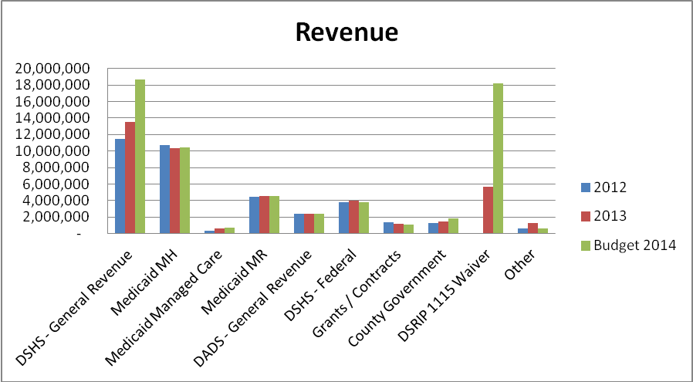

General Revenue
The amount of state general revenue received by the Center has decreased during the past thirteen (13) years. The funding helped balance the impact of cuts made and “forced” the statewide Community MHMR Centers to become more efficient. See graph below:

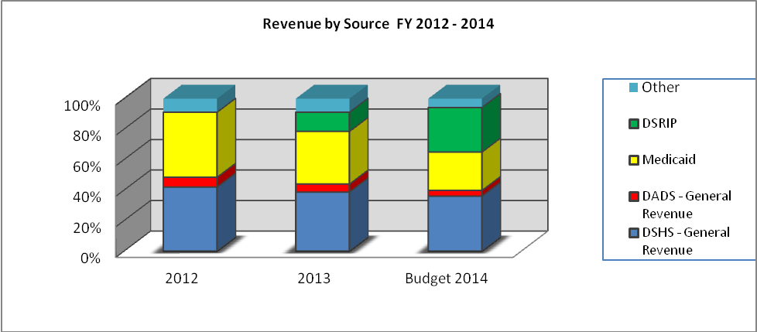

MH General Revenue FY 2014 is expected to be $18,678,272 compared to $13,483,995 in FY 2013. The increase is primarily due to funding from DSHS for the new and exceptional items as well as a new Substance Abuse Detoxification program.

IDD General Revenue FY 2014 is expected to be $2,357,788 compared to $2,360,901 in FY 2013. The decrease was primarily due to a slight reduction in the funding for Permanency Planning.

Medicaid Revenue

Medicaid revenue was $14,936,333 in FY 2013, and is budgeted to be $14,993,907 in FY 2014. The steady increase in Medicaid revenues since FY 2005 is due to an increase in the number of services delivered and also an increase in the number of our clients covered by Medicaid as well as the fact that Medicaid started being paid at 100% in FY 2010.

The Center’s goals include a further expansion of revenue received from Medicaid and other sources. Procedures implemented to expand Medicaid revenue include the following:
- Four (4) staff dedicated to assisting MH and MR consumers access Social Security and Medicaid benefits. Two (2) staff to assist consumers in the Texas Council on Offenders with Mental Impairments (TCOOMMI) programs.
- Six (6) staff dedicated to assist in getting pre-authorizations needed with the expansion of Medicaid managed care.
- Training staff in verifying and data entering the payor source for every consumer during each visit to a mental health program.
- Monitoring the percent of consumers with Medicaid to determine if there is an increase.
- Comparing the Medicaid data base with our Consumer Data system to determine if any consumers have third-party coverage which was not previously identified.

Other Revenue Sources
In FY 2014, the Center budgeted $22,510,516 from other revenue sources compared to $10,313,999 in FY 2013. The increase is due mainly to the 1115 DSRIP projects and the revenues we anticipate receiving for meeting those metrics.

The Center continues to expand and diversify the funding sources through various grants and contracts. The Center also continues to explore the possibility of applying for a Section 501(c)(3) designation with the Internal Revenue Service if its status as a political subdivision of the State ever changes. The designation will allow the Center to continue to qualify for grants awarded by foundations, certain federal agencies, and federal pass-through grants such as Community Development Block Grants.

Fund Balance
The Center’s fund balance in the General Fund, as of August 31, 2013, was $13,083,853 and was $7,941,887 at the end of 2012. The Center has had a positive fund balance since FY 2001 and it has continuously grown since 2003. The decrease in 2011 is due to a resolution from the Board of the Center to commit funds to the capital projects fund for planned construction.

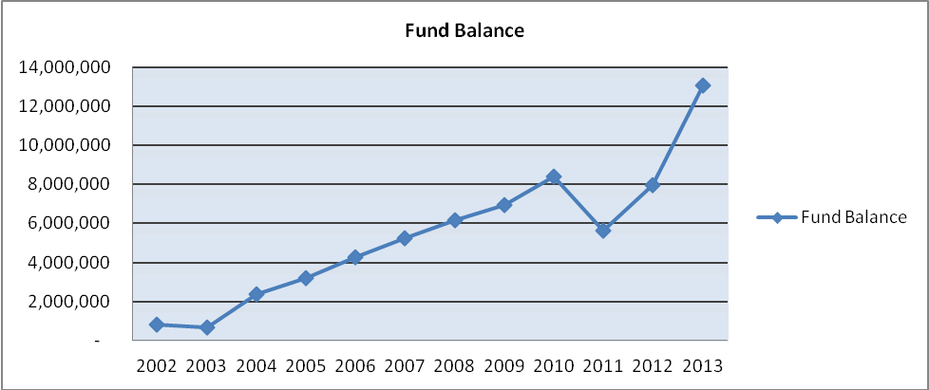

Financial Ratios

The following financial ratios are completed monthly to monitor the liquidity, days of operating cash available and debt load. The ratios were developed by Capital Markets in order to have an industry standard for Texas Community MHMR Centers.

- Current Ratio The ability to meet short-term obligations. This is presented in
“times”. If the ratio is too low, the Center may not be able to pay its obligations. If the ratio is too high, the Center may have money tied up in investments/savings that could be used for the provision of services.
Acceptable range for community centers: 1.75 – 4.00
Ratio at August 31, 2013 3.62 Times

- Quick Ratio / A more stringent measure of liquidity. Eliminates the variable of
Acid Test Ratio Converting investments and other tangible assets to cash.
Acceptable range for community centers: .025 – 2.00
Ratio at August 31, 2013 3.04 Times

- Days of Operation Expresses the cash position of the organization in terms of the
Reserve number of days it can operate if there was no further inflow of
revenue. Represented in days.
Acceptable range for community centers: 60 – 90
Ratio at August 31, 2013 135.92 Days

- Debt Service A measure of how well the Center has managed the assumption Coverage Ratio of long-term debt. Indicates available cash levels to
accommodate debt service payments. Represented in “times”.
Acceptable range for community centers: > 1.25
Ratio at August 31, 2013 15.33 Times

The ratios are included in the monthly financial statement packet presented to the Board of Trustees. The ratios reported are limited to the General Fund.

Financial ratios are also a key component of the internal monitoring system for the Center. The following graph outlines the acceptable minimum ranges and the Centers ratios. We have consistently been meeting the acceptable ranges and do not anticipate any changes in the near future.
Financial Ratios
Community Services Performance Report
August 31
Financial Measure | 2012 | 2013 | Minimum  Acceptable Range | Maximum  Acceptable Range
Current Ratio | 2.51 | 3.62 | 1.75 | 4.00
Acid Test Ratio | 1.93 | 3.04 | 0.25 | 2.00
Debt Service Coverage Ratio | 4.73 | 15.33 | 1.25 | Unlimited
Days of Operation without Further Funding | 94.83 | 135.92 | 60.00 | 90.00

The strategic goals included having a 60-110 day operating reserve. An increased emphasis on maximizing revenue sources and holding expenses constant should assist the Center in achieving the goal.

Expenditures

The Center’s FY 2014 adjusted operating budget totaled $58,440,093. As with other service industry organizations, the majority of the expenses are for personnel costs. FTE’s in FY 2013 were 495.4 and budgeted FTE’s for FY 2014 are 707.9. The increased positions are to be funded by Medicaid revenues.

FY13 fringe rate is 22.37% and our anticipated FY14 is 25.89% due to a change in workman’s compensation costs and an increase the retirement match. We are not anticipating an increase in health insurance.

Medications expense represents approximately 5% of our FY 2013 operating budget, and will be 7% for the FY 2014. In FY 2010 we contracted with US Scripts to provide to provide a choice to clients who preferred to get their medications from a retail pharmacy. US Scripts provided the Center with valuable information regarding prescribing patterns and suggestions on how to reduce costs by changing doses of the same medication. Significant work has been completed to date to reduce the expense. The most significant initiative was the expansion of the Patient Assistance Program (PAP). PAP allows the Center to request medications on behalf of eligible consumers directly from the manufacturer. FY13 PAP 4,325 applications submitted were for a value of $4,573,150.

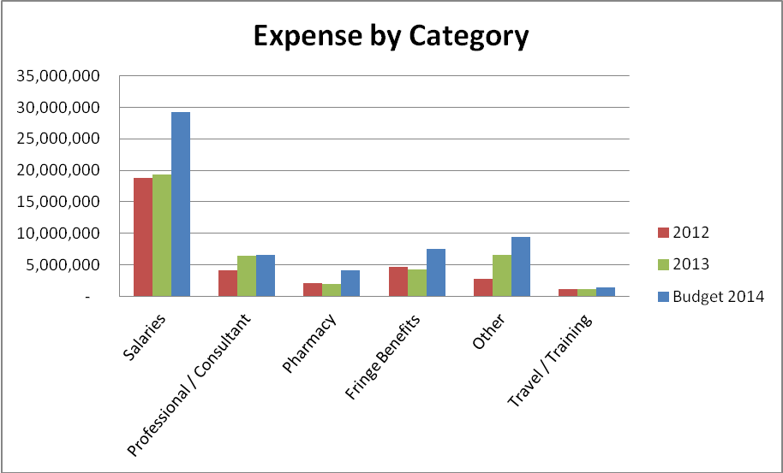

Indirect Cost

The Center uses the indirect cost percentage as an indicator of its administrative efficiency. The indirect cost is a relationship of the administrative costs to the direct / program costs. The indirect cost percentage was calculated in accordance with the Audit Guidelines for Community MHMR Centers, 20th Revision – summer 2003, the cost principles in the OMB Circular A-87 and the Cost Accounting Methodology promulgated by Health & Human Services.

The following graph shows the indirect cost percentage for the past eleven (11) years as well as the estimated indirect cost rate for FY 2013. The guidelines used have changed during that time period which contributed to the variances.

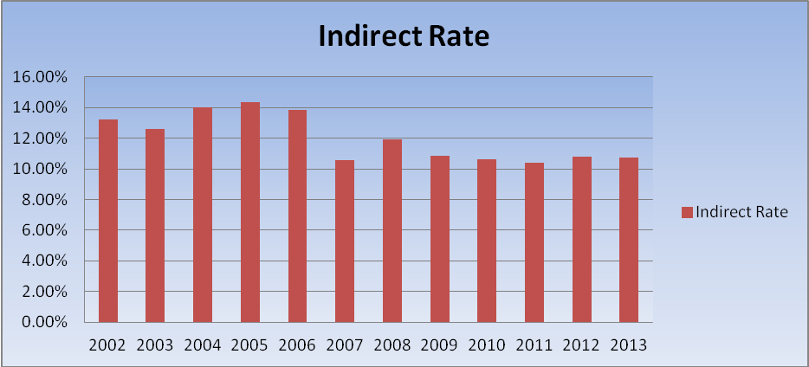

The Center’s Performance Contract with DSHS and DADS includes a 10% funding limitation for state general revenue that can be used to fund administrative costs. Any additional funding needs are covered by various other funding streams. The Center has successfully demonstrated the ability to operate within the funding limitation.

The indirect cost percentage as of August 31, 2013 was 10.71%. Administrative costs are monitored closely to determine where reductions can be made without doing harm to the programs or the Center’s system of internal controls.

Capital Projects

The Center has completed construction on the Harlingen building. The new building in Harlingen has consolidated all of our main services into one (1) building. We are currently in the process of completing the renovation of the Edinburg building, which is anticipated to cost approximately $3.7 M and to be completed prior to the end of FY 2014. The Center is also working on plans to construct an addition to the current building in Brownsville and to purchase a building in Weslaco.

The Center fleet has also been evaluated and plans to update aging equipment have been identified. Currently we have an inventory of 53 vehicles consisting of 24 sedans, 17 standard vans, 10 passenger vans and 2 pick-up trucks.

Other items in the infancy stage for projects are:

- Replacement of existing “aged” computers and printers
- On-line Time and Attendance system utilizing Biometric clocks
- Telephone system upgrade to an IP System
- Financial software system to provide the growing needs of the Center

1115 Waiver and Other Considerations

In FY 2012 HHSC received federal approval of a waiver that allowed the state to expand Medicaid managed care programs, the waiver provided incentives for health care improvements. The waiver called for Regional Healthcare Partnerships (RHP) comprised of counties. The RHP’s were allocated a dollar amount based on its population that is under 200% of the federal poverty level. TTBH belongs to RHP 5 which is comprised of 4 counties, Hidalgo, Willacy, Cameron and Starr. The RHP’s first allocation was approximately $801,878,997. Of the money allocated to our RHP $294,862,928 was approved in the first pass to the entire RHP 5 for DSRIP projects. This allocation is for demonstration years 1-5. HHSC later reallocated the money left over within the RHP's and gave RHP 5 $381,973,983 which allowed those performing providers within the RHP the ability to submit additional projects for consideration.

TTBH’s portion approved by HHSC for the first pass consisted of 12 projects valued at $109,982,999 for all 5 years. Under the rules, TTBH is considered both a performing provider and an IGT entity. The waiver is a matching program, IGT entities send approximately 40% and it is matched with 60% for the total of the allocation. It is estimated that TTBH will have $83,662,234 IGT available for the 5 year program. TTBH submitted three (3) additional projects in Pass 2 with a total value of $23,647,018. The combined total submitted for the 12 initial projects and the 3 additional projects is $133,630,017. If all are approved TTBH would need to IGT approximately $53,452,007 over the course of 5 years.

Anticipated 1115 Waiver project related costs:
• Facility space to house approximately 130 additional fte’s
• Facility space to house our peer drop in centers.
• Technology to provide the services including telemedicine equipment and connectivity from the community at large
• Vehicles for transportation of clients
• Vehicles for our MH Taskforce services
• Vehicles and supplies for our Mobile Clinics
• Recruitment
• Training
• Equipment for the additional fte's
• Medical equipment and supplies for our primary care services
• New telephone system

