Sun. | Mon. | Tue. | Wed. | Thu. | Fri. | Sat.
 |  |  | Hours of Operation: |  | Mobile Unit #
 | 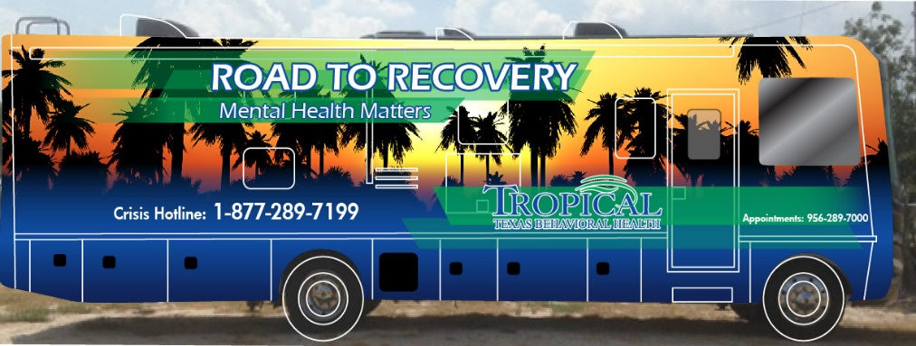 |  | Tue.- Fri. 10am-6pm  Sat. 9am-11pm |  | 956-478-2492
 |  | 1 | 2 | 3 | 4 | 5
 |  | Call Mobile Number | Call Mobile Number | Call Mobile Number | Call Mobile Number | Call Mobile Number
6 | 7 | 8 Raymondville | 9 La Sara | 10 Harlingen | 11 Harlingen | 12 La Feria
 |  | First United Methodist Church  192 S. 3rd St. | Community  Resource Center  706 East Sixth Street | Outreach Center  1102 S Commerce | Westbrook Clinic  2306 Camelot Drive | Sports Complex  904 Pancho Maples Dr.
  (1pm-6pm)
13 | 14 | 15 Brownsville | 16 Brownsville | 17 Port Isabel | 18 Brownsville | 19 San Benito
 |  | VAC HIV/STI Edu.  857 E. Washington ST. Suite G | Good Neighbor  1254 East Tyler Street | Walmart Supercenter  1401 TX-100 | Valle Escondido  9901 California Rd | Walmart Supercenter  1126 W US Highway 77
20 | 21 | 22 Raymondville | 23 La Sara | 24 Harlingen | 25 Harlingen | 26 La Feria
 |  | First United Methodist Church  192 S. 3rd St. | Community  Resource Center  706 East Sixth Street | Outreach Center  1102 S Commerce | Westbrook Clinic  2306 Camelot Drive | Sports Complex  904 Pancho Maples Dr.
 |  |  | resnos
27 | 28 | 29 Brownsville  VAC HIV/STI Edu.  857 E. Washington ST. Suite G | 30 Brownsville  Good Neighbor  1254 East Tyler Street | 31 Port Isabel  Walmart Supercenter  1401 TX-100

